
Foreign interference harms
the rights and freedoms
of people in New Zealand
The New Zealand Security Intelligence Service (NZSIS) defines foreign interference as an act by a foreign state, often acting through a proxy, which is intended to influence, disrupt or subvert New Zealand’s national interests by deceptive, corruptive or coercive means. Normal diplomatic activity, lobbying and other genuine, overt efforts to gain influence are not considered interference.
In this information sheet “foreign state” means any country other than
New Zealand. This term is used to refer to countries outside of New Zealand.

Foreign interference harms the rights
and freedoms of Ethnic Communities
Foreign interference is when foreign states try to interfere with New Zealand to achieve their own goals. These foreign states want to control and change New Zealand’s society, interests, and behaviours. They do this so they can have more influence and control.

Foreign interference damages New Zealand’s independence, democracy, economy, reputation, and communities. Ethnic Communities in New Zealand can get unwanted attention from foreign states, making them feel unsafe and harming their rights and freedoms. Normal diplomatic activities between countries are not foreign interference.


How can foreign interference
happen to Ethnic Communities?

Foreign interference experienced by Ethnic Communities can be hard to see. Here are some examples of foreign interference activities by a foreign state or someone doing foreign interference for them in New Zealand:

- trying to control and intimidate communities or community organisations/groups
- refusing to process or issue official documents to harass, intimidate and control communities and their actions
- taking away or threatening to take away visas, passports, or other official documents of people in New Zealand to harass, intimidate and control communities and their actions
- threatening people in New Zealand, or their families who live overseas (including threats and harassment through social media)
- forcing people to return to their country of origin against their will
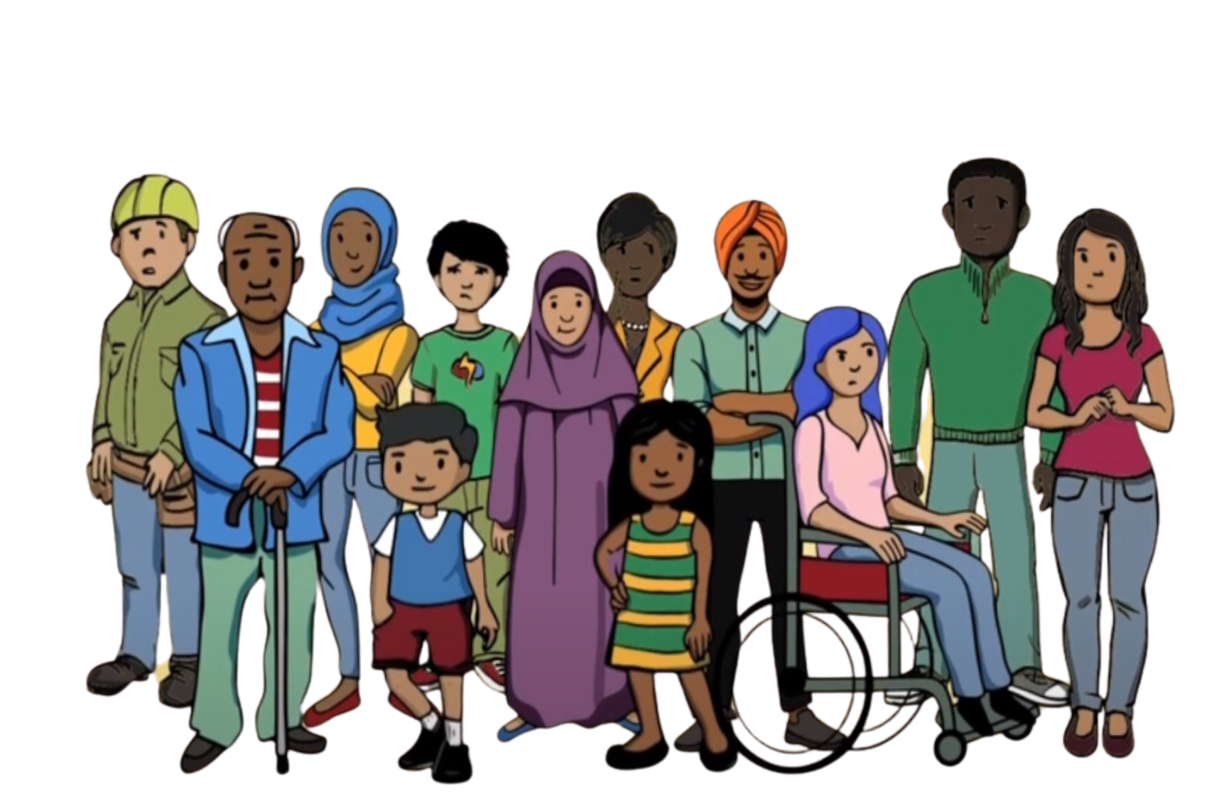
- unauthorised surveillance and monitoring of the community by a foreign state to threaten or intimidate people

- trying to prevent certain groups or communities from openly sharing their views or opinions that are different from those of the foreign state by using threats or intimidation
- trying to stop events from happening in New Zealand to prevent people from expressing their opinions or beliefs that a foreign state disagrees with
- passing on threats from a foreign state to the community in New Zealand
- trying to change how elections and other democratic processes work

