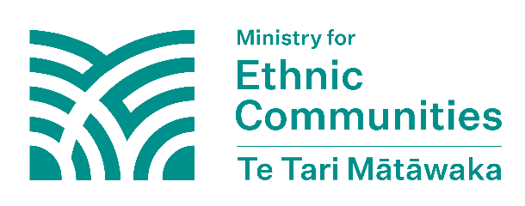
Your rights in New Zealand
This is general information about rights in New Zealand. It is for your understanding only and is not legal advice. For specific legal advice, talk to a qualified legal professional.

Foreign interference harms the rights and freedoms of people in New Zealand. This fact sheet provides information on the rights and freedoms that are protected in New Zealand.
In New Zealand, civil rights, political rights, and freedoms are primarily protected under two key pieces of legislation: the Human Rights Act 1993 and the New Zealand Bill of Rights Act 1990.

Human Rights Act 1993
The Human Rights Act 1993 is aimed at giving all people equal opportunities and preventing unfair treatment because of irrelevant personal characteristics. It applies to everyone in New Zealand, including non-citizens and people who are not lawfully here.

The reasons you can’t discriminate against someone under this Act:
- Race, colour, ethnic or national origins
- Sex (including pregnancy and childbirth)
- Marital status
- Religious belief
- Ethical belief
- Disability
- Age
- Political opinion
- Employment status
- Family status
- Sexual orientation


New Zealand Bill of Rights Act 1990

The New Zealand Bill of Rights Act 1990 (BORA) aims to protect and promote the civil and political rights for people in New Zealand, ensuring their fundamental freedoms are upheld.
Unless a section specifies that a right is only for New Zealand citizens or those lawfully in New Zealand, the rights apply to everyone in New Zealand.
Note: This is not a full list of the sections in the New Zealand Bill of Rights Act 1990. For the full text, see the Act here.

Section 8
Right not to be
deprived of life
“Everyone has the right not to be deprived of life except on such grounds as are established by law and are consistent with the principles of fundamental justice.”
Section 9
Right not to be subjected to torture or cruel treatment
“Everyone has the right not to be subjected to torture or to cruel, degrading, or disproportionately severe treatment or punishment.”
Section 12
Electoral rights
“Every New Zealand citizen who is of or over the age of 18 years has the right to vote in genuine periodic elections of members of the House of Representatives, which elections shall be by equal suffrage and by secret ballot.”
Section 13
Freedom of thought, conscience, and religion
“Everyone has the right to freedom of thought, conscience, religion, and belief, including the right to adopt and hold opinions without interference.”
Section 14
Freedom of expression
“Everyone has the right to freedom of expression, including the freedom to seek, receive, and impart information and opinions of any kind in any form.”
Section 15
Manifestation of
religion and belief
“Every person has the right to manifest that person’s religion or belief in worship, observance, practice, or teaching, either individually or in community with others, and either in public or in private.”

Section 16
Freedom of
peaceful assembly
“Everyone has the right to freedom of peaceful assembly.”

Section 17
Freedom of association
“Everyone has the right to freedom of association.”
Section 18
Freedom of movement
“Everyone lawfully in New Zealand has the right to freedom of movement and residence in New Zealand.”
Section 19
Freedom from discrimination
“Everyone has the right to freedom from discrimination on the grounds of discrimination in the Human Rights Act 1993.”
Section 20
Rights of minorities
“A person who belongs to an ethnic, religious, or linguistic minority in New Zealand shall not be denied the right, in community with other members of that minority, to enjoy the culture, to profess and practise the religion, or to use the language, of that minority.”
Section 27
Right to justice
“Every person has the right to the observance of the principles of natural justice by any tribunal or other public authority which has the power to make a determination in respect of that person’s rights, obligations, or interests protected or recognised by law.”

Learn more about your rights
Human Rights Commission: The Commission offers guidance and support on human rights issues. They can give you information and help with complaints about discrimination and other human rights issues. Find out more on the Human Rights Commission website: https://www.hrc.co.nz
Community Law Centres: The centres have free legal help and support to individuals and communities across New Zealand. This may include easy-to-read information, community workshops and one-to-one legal help. Find out more on the Community Law website: https://communitylaw.org.nz
Citizens Advice Bureau (CAB): The bureau has free, confidential information and advice on a wide range of topics including legal help, rights, and government services. Contact your nearest CAB office or find out more on the CAB website: https://www.cab.org.nz/

